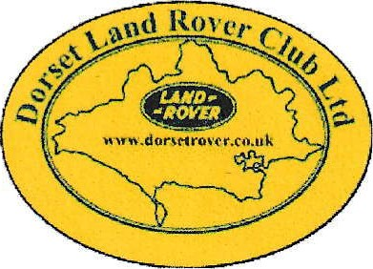
Membership Application Form
Dorset Land Rover Club Ltd
(Membership is for you, your partner, plus children up to 18 yrs of age)
Please complete all sections

Name: ……………………………………………………………………………………………………………………
Address: ………………………………………………………………………………………………………………...
……………………………………………………………………………………………………………………………..
……………………………………………………………………………………………………………………………..
……………………………………………………………………………………………………………………………..
Post Code: …………………….
Phone: ………………………………………….. Mobile: ……………………………………………………………
Please ensure you provide an Email Address
Email: …………………………………….…..………………………………………………………………………….
Annual Subscription including electronic PDF magazine £30:00 p.a.
Under the terms of our Child Protection Policy, publication of images including children attending our Land Rover events is prohibited unless we have their parent/guardian’s consent to do so. Please tick the box if you are happy for images taken of children in your care to be used in the promotion of the club
I hereby give permission for images of children in my care to be used in the promotion of DLRC Ltd. (please tick the box above to indicate agreement)
Signed: ………………………………………………………………………………..
Date: ………………………………………………………………………………..
DATA PROTECTION
Please tick this box if you are happy for the club to use the information in this form to contact you regarding forthcoming events
(We will not pass any of this information on to anyone else!)

Please pay by direct bank transfer Bank Code: 30-99-12 Sort Code: 01825212 include your Club membership number in the reference box of the transfer. Please send an email (membership@dorsetrover.com) with a copy of this document (a phone photo will do)
You can also pay by cheque payable to Dorset Land Rover Club Ltd and write your address and Club membership number on the back and send it along with this form to
Mike Mears
DLRC Ltd Membership Secretary
38 Hercules Road
Hamworthy
Poole
BH15 4JA

